**Brain Tumor Classification using CNN and**  **Transformers**

**Class: Computer Vision CSC 752 -U18**

**Department of Computer Science**

**University of South Dakota**

**Group members:**

**Neerajdattu Dudam**

**Nagamani Motupalli**

**Madhu Sree Sane**

**Mounika Bollina**

**Supervisor: Dr. Lina Chato**

**Fall 2024**

# Objective

This project aims to use cutting-edge computer vision and machine learning techniques to create a reliable and accurate system for identifying brain tumors. We want to:

* Classify brain tumors using Convolutional Neural Networks (CNNs) according to a supplied data set.
* Test different network topologies and layer configurations to maximize categorization execution.
* Compare our proprietary CNN models with cutting-edge models like ResNet50.
* Examine the application of transformers, such as the Vision and Swin transformers. to improve the performance of the model.
* Apply transfer learning to enhance categorization by utilizing taught models after training. precision and effectiveness.
* Perform a thorough analysis of the benefits and disadvantages of each strategy to determine the best method for classifying brain tumors.

# Data

The dataset utilized in this study will consist of medical imaging data, primarily MRI images of brain tumors. The following will be included in the dataset:

* High-resolution pictures of brain tumors that have been classified with the kind of tumor; the dataset consists of four classes with labels. There are total of 7000 images including training and testing.
* Images that have been pre-processed to ensure consistency and quality for model testing and training.
* To accurately assess the performance of the model, the dataset is divided into training and test sets.
* Link for the dataset - <https://www.kaggle.com/datasets/masoudnickparvar/brain-tumor-mri-dataset>

# Hypothesis

We hypothesize that complex machine learning models—in particular, CNNs and transformers—can greatly increase the classification accuracy of brain tumors. We think that:

* Custom CNN models will achieve excellent classification accuracy when optimized with different architectures and layers.
* Cutting-edge models such as ResNet50 will offer a solid baseline for comparison.
* Transformers with the capacity to extract complex patterns from the image data, like the Swin and Vision Transformers, will function better.
* By using the information from previously trained models on big datasets, transfer learning will increase classification accuracy even further.
* An extremely effective and efficient approach for classifying brain tumors will be created by combining these techniques.

# Expectations

We expect the following outcomes from our project: Creation of an efficient CNN model specifically for the categorization of brain tumors:

* Determining the best layer configuration and network architecture for our unique models.
* A thorough analysis of the differences in performance between our customised designs and cutting-edge models such as ResNet50.
* Proof of the transformers' ability to improve classification performance.
* The effective application of transfer learning, which enhances efficiency and accuracy.
* Understanding the advantages and disadvantages of each approach, offering insightful information for the next studies and advancements in medical imaging and diagnostics.

By reaching these goals, we want to improve patient outcomes and treatment plans by furthering the development of medical imaging technologies and provide a trustworthy instrument for the early diagnosis and categorization of brain tumors.

# Project Process and Design

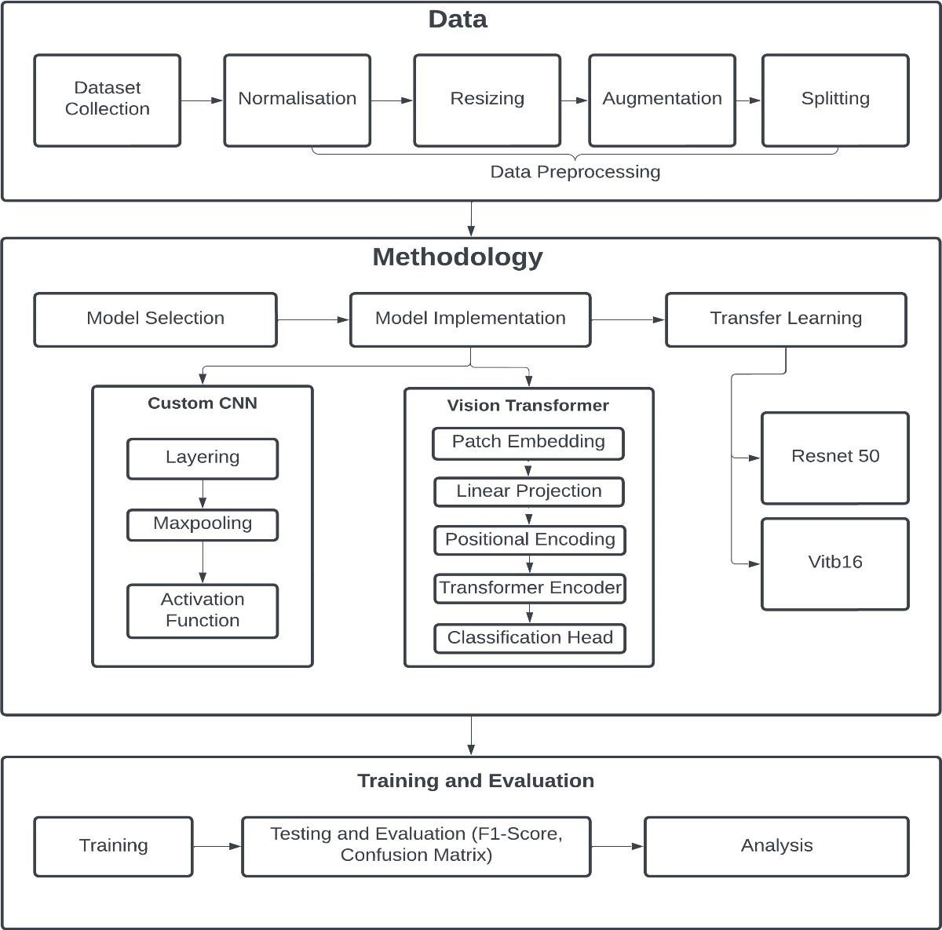

# 6. References

1. Sharma, N., Jain, V., Mishra, A. (2018). An analysis of convolutional neural networks for image classification. Procedia Computer Science, 132, 377–384. https://doi.org/10.1016/j.procs.2018.05.198
2. M. Nickparvar. ”Brain tumor MRI dataset,” in Kaggle, 2021.
3. PyTorch, ”ViT-B/16: Vision Transformer with BERT-style tokens,” PyTorch torchvision

Library.

1. J. Cheng, ”Brain tumor dataset,” 2017.
2. J. Sarta, ”Brain tumor classification (MRI),” in Kaggle, 2020.
3. A. Hamada, ”Br35H:: Brain tumor detection 2021,” in Kaggle, 2020.
4. R. Samy, ”Brain tumor using CNN,” in Kaggle, 2024.
5. K. Tian, ”Brain tumor type classification- VGG-19,” in Kaggle, 2024.
6. A. Dosovitskiy et al., “AN IMAGE IS WORTH 16X16 WORDS: TRANSFORMERS FOR

IMAGE RECOGNITION AT SCALE,” in ICLR 2021- 9th International Conference on Learning Representations, 2021.

1. Lorente, ` O., Riera, I., Rana, A. (2021, May 11). Image Classification with Classic and Deep Learning Techniques. arXiv.org. https://arxiv.org/abs/2105.04895